
Holiday
Craft & Gift FAIR
DEC 12-13
10am-5pm
Over 100 Vendors
Smithtown HS East
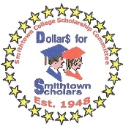
10 School Street, St James NY 11780
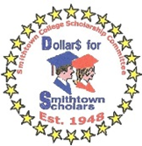
For info 631 846 1459

Sponsored by
Smithtown College Scholarship
A committee of Smithtown Council of PTAs
CSC@Yahoo.com
“Approval for distribution of these materials is not an endorsement of such services, activities and/or products by the Smithtown School District.”

