Smithtown College Scholarship Committee
presents

An Evening of Magic
Starring
John Reid

An all new comedy magic show with music and live animals. Volunteers assist during the performance and one of them is levitated in the finale!
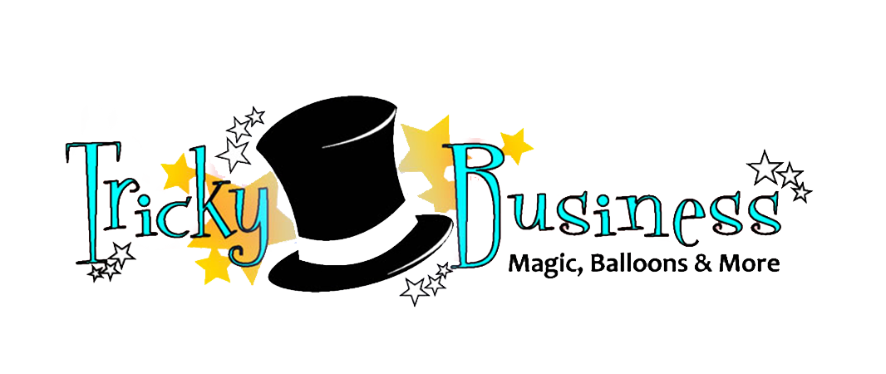

Friday, March 13, 2015 7:00pm
Great Hollow MS Gymnasium
Southern Blvd., Nesconset

In advance (BY MAIL)
$6.00 ADULTS $5.00 CHILDREN

AT DOOR (IF AVAILABLE)
$8.00 ADULTS $6.00 CHILDREN

REFRESHMENTS WILL BE SOLD

MAIL WITH CHECK PAYABLE TO SMITHTOWN COLLEGE SCHOLARSHIP COMMITTEE, TO
SCSC, PO BOX 497, SMITHTOWN, NY 11787 Attention: Magic Show (on outside of envelope)

NO TICKETS WILL BE ISSUED. A ROSTER WILL BE HELD AT THE DOOR.
QUESTIONS? Contact us at SmithtownCSC@yahoo.com or 360-1407

Save with Family Pack—see below
-------------------------------------------------------------------------------------------------------------------------------

Name__________________________________________________Email/phone___________________________________

___________Family Pack (2 adults 2 children $20)

___________Adults @$6.00 ___________Children @ $5.00

Elementary School your child attends_________________________________________

